Case Study: 3
Title: To design a web application with a login system that allows only authenticated users to access a Semester Grade Sheet, where students can enter their marks and get their SGPA calculated automatically.
Software/Tools Required: VSC, HTML, CSS, JavaScript
Case Study program code:
INDEX:
<!DOCTYPE html>
<html lang="en">
<head>
<meta charset="UTF-8">
<meta name="viewport" content="width=device-width, initial-scale=1.0">
<title>Semester Grade Sheet</title>
<style>
:root{
--deep: #0b3a56;
--deep2: #114f74;
--mid: #1c6f9c;
--sky: #cfe3f5;
--sky-light: #eaf3fb;
--ink: #0b2436;
--card-bg: rgba(255,255,255,0.86);
--glass-border: rgba(255,255,255,0.5);
}

*{ box-sizing: border-box; }

body{
margin:0;
min-height:100vh;
font-family: 'Segoe UI', system-ui, -apple-system, sans-serif;
color: var(--ink);
padding: 40px 16px 64px;
background:
radial-gradient(circle at 50% 38%, var(--mid) 0%, var(--deep2) 45%, var(--deep) 100%);
display:flex;
justify-content:center;
}

.sheet{
width: 100%;
max-width: 820px;
background: var(--card-bg);
backdrop-filter: blur(18px);
border: 1px solid var(--glass-border);
border-radius: 24px;
box-shadow: 0 30px 60px -20px rgba(6,25,40,0.55), 0 0 0 1px rgba(255,255,255,0.3) inset;
overflow: hidden;
position: relative;
}

.sheet::before{
content:"";
position:absolute;
top:0; left:0; right:0;
height: 6px;
background: linear-gradient(90deg, var(--deep), var(--mid), var(--sky));
}

header{
padding: 34px 40px 20px;
text-align:center;
background: linear-gradient(180deg, var(--sky-light) 0%, rgba(234,243,251,0) 100%);
}

.eyebrow{
font-size: 11px;
letter-spacing: 3px;
color: var(--mid);
text-transform: uppercase;
font-weight: 700;
margin: 0 0 8px;
}

h1{
font-size: 30px;
font-weight: 800;
margin: 0 0 4px;
color: var(--deep);
letter-spacing: -0.5px;
}

.subhead{
font-size: 13px;
color: #4a6376;
margin: 0;
}

.student-block{
padding: 22px 40px 4px;
display:grid;
grid-template-columns: 1fr 1fr;
gap: 16px;
}

.field{
display:flex;
flex-direction: column;
gap: 6px;
}

.field label{
font-size: 11px;
font-weight: 700;
letter-spacing: 1px;
text-transform: uppercase;
color: var(--mid);
}

.field input[type="text"]{
padding: 11px 14px;
border-radius: 12px;
border: 1.5px solid rgba(28,111,156,0.25);
background: #fff;
font-size: 14px;
color: var(--ink);
font-family: inherit;
}

.field input[type="text"]:focus{
outline: none;
border-color: var(--mid);
box-shadow: 0 0 0 3px rgba(28,111,156,0.15);
}

.grid{
padding: 26px 40px 8px;
}

table{
width: 100%;
border-collapse: collapse;
margin-bottom: 10px;
}

thead th{
text-align: left;
font-size: 10.5px;
letter-spacing: 1.5px;
text-transform: uppercase;
color: var(--mid);
font-weight: 700;
border-bottom: 2px solid rgba(28,111,156,0.2);
padding: 8px 10px;
}

tbody td{
padding: 12px 10px;
border-bottom: 1px solid rgba(28,111,156,0.12);
vertical-align: middle;
}

.code-cell{
font-weight: 800;
font-size: 15px;
color: var(--deep);
}

.code-cell small{
display:block;
font-weight: 500;
font-size: 11px;
color: #6b7d8a;
margin-top: 2px;
}

input[type="number"]{
width: 68px;
padding: 8px 10px;
border-radius: 10px;
border: 1.5px solid rgba(28,111,156,0.25);
background: #fff;
font-size: 14px;
color: var(--ink);
font-family: inherit;
}

input[type="number"]:focus{
outline: none;
border-color: var(--mid);
box-shadow: 0 0 0 3px rgba(28,111,156,0.15);
}

.credit-badge{
font-size: 11px;
color: #6b7d8a;
background: rgba(28,111,156,0.08);
padding: 3px 8px;
border-radius: 999px;
}

.grade-pill{
display:inline-block;
min-width: 36px;
text-align:center;
padding: 5px 10px;
font-weight: 800;
font-size: 12.5px;
border-radius: 999px;
color: var(--ink);
}

.grade-O{ background:#c9ecd6; }
.grade-Aplus{ background:#d8edc4; }
.grade-A{ background:#eee7b8; }
.grade-Bplus{ background:#f3d9a6; }
.grade-B{ background:#f2c79a; }
.grade-C{ background:#efb298; }
.grade-P{ background:#eba099; }
.grade-F{ background:#e28080; color:#4a1111; }

.result{
margin: 10px 40px 26px;
border-radius: 18px;
background: linear-gradient(135deg, var(--deep) 0%, var(--mid) 100%);
color: #eaf3fb;
padding: 22px 26px;
display:flex;
justify-content: space-between;
align-items: center;
flex-wrap: wrap;
gap: 16px;
box-shadow: 0 12px 30px -8px rgba(11,58,86,0.55);
}

.result .label{
font-size: 11px;
letter-spacing: 2px;
text-transform: uppercase;
color: var(--sky);
margin: 0 0 4px;
font-weight: 700;
}

.result .value{
font-size: 38px;
font-weight: 800;
margin: 0;
}

.result .who{
font-size: 12px;
color: var(--sky);
margin: 2px 0 0;
}

.result .remark{
font-size: 13px;
color: #d7e8f4;
max-width: 260px;
text-align: right;
}

footer{
padding: 0 40px 30px;
display:flex;
justify-content: space-between;
align-items:center;
gap: 12px;
flex-wrap: wrap;
}

button{
font-family: inherit;
font-weight: 700;
letter-spacing: 0.5px;
font-size: 13px;
padding: 12px 22px;
border-radius: 12px;
border: none;
cursor: pointer;
transition: transform 0.12s ease, box-shadow 0.12s ease;
}

#calcBtn{
background: linear-gradient(135deg, var(--mid), var(--deep));
color: #fff;
box-shadow: 0 8px 18px -6px rgba(28,111,156,0.6);
}

#resetBtn{
background: rgba(28,111,156,0.1);
color: var(--deep);
}

button:hover{ transform: translateY(-1px); }
button:active{ transform: translateY(0); }
button:focus-visible{ outline: 2px solid var(--mid); outline-offset: 2px; }

.scale-note{
font-size: 11px;
color: #6b7d8a;
flex: 1;
min-width: 200px;
}

@media (max-width: 600px){
header, .student-block, .grid, .result, footer{ padding-left: 22px; padding-right: 22px; }
.student-block{ grid-template-columns: 1fr; }
.result{ flex-direction: column; align-items: flex-start; }
.result .remark{ text-align: left; }
input[type="number"]{ width: 56px; }
}

/* ---- Login overlay ---- */
#loginOverlay{
position: fixed;
inset: 0;
background: radial-gradient(circle at 50% 38%, var(--mid) 0%, var(--deep2) 45%, var(--deep) 100%);
display:flex;
justify-content:center;
align-items:center;
padding: 16px;
z-index: 1000;
}

#loginOverlay .login-card{
width: 100%;
max-width: 400px;
background: var(--card-bg);
backdrop-filter: blur(18px);
border: 1px solid var(--glass-border);
border-radius: 24px;
box-shadow: 0 30px 60px -20px rgba(6,25,40,0.55), 0 0 0 1px rgba(255,255,255,0.3) inset;
overflow: hidden;
position: relative;
}

#loginOverlay .login-card::before{
content:"";
position:absolute;
top:0; left:0; right:0;
height: 6px;
background: linear-gradient(90deg, var(--deep), var(--mid), var(--sky));
}

#loginOverlay header{
padding: 34px 36px 16px;
}

#loginOverlay h1{
font-size: 24px;
}

#loginOverlay form{
padding: 18px 36px 6px;
display:flex;
flex-direction: column;
gap: 16px;
}

#loginOverlay .field label{
font-size: 11px;
font-weight: 700;
letter-spacing: 1px;
text-transform: uppercase;
color: var(--mid);
}

#loginOverlay .field input{
width: 100%;
padding: 11px 14px;
border-radius: 12px;
border: 1.5px solid rgba(28,111,156,0.25);
background: #fff;
font-size: 14px;
color: var(--ink);
font-family: inherit;
}

#loginOverlay .field input:focus{
outline: none;
border-color: var(--mid);
box-shadow: 0 0 0 3px rgba(28,111,156,0.15);
}

#loginError{
font-size: 12.5px;
color: #b23b3b;
min-height: 16px;
margin: -4px 0 0;
}

#loginOverlay footer{
padding: 6px 36px 30px;
display:flex;
flex-direction: column;
gap: 10px;
}

#loginBtn{
width: 100%;
background: linear-gradient(135deg, var(--mid), var(--deep));
color: #fff;
box-shadow: 0 8px 18px -6px rgba(28,111,156,0.6);
}

.login-hint{
font-size: 11px;
color: #6b7d8a;
text-align:center;
}

body.locked > .sheet{
display: none;
}
</style>
</head>
<body class="locked">

<div id="loginOverlay">
<div class="login-card">
<header>
<p class="eyebrow">B.Tech &middot; Computer Science &amp; Engineering</p>
<h1>Student Login</h1>
<p class="subhead">Sign in to access your Semester Grade Sheet</p>
</header>

<form id="loginForm">
<div class="field">
<label for="loginUsername">Username</label>
<input type="text" id="loginUsername" placeholder="e.g. student" autocomplete="username" required>
</div>
<div class="field">
<label for="loginPassword">Password</label>
<input type="password" id="loginPassword" placeholder="Enter password" autocomplete="current-password" required>
</div>
<p id="loginError"></p>
</form>

<footer>
<button id="loginBtn" type="submit" form="loginForm">Login</button>
<p class="login-hint">Demo credentials — username: <b>student</b>, password: <b>1234</b></p>
</footer>
</div>
</div>

<div class="sheet">
<header>
<p class="eyebrow">B.Tech &middot; Computer Science &amp; Engineering</p>
<h1>Semester Grade Sheet</h1>
<p class="subhead">Enter your details and marks to compute grade points and SGPA</p>
</header>

<div class="student-block">
<div class="field">
<label for="studentName">Student Name</label>
<input type="text" id="studentName" placeholder="e.g. Aarav Sharma">
</div>
<div class="field">
<label for="studentPRN">PRN</label>
<input type="text" id="studentPRN" placeholder="e.g. 22070123456">
</div>
</div>

<div class="grid">
<table id="gradeTable">
<thead>
<tr>
<th>Subject</th>
<th>Credits</th>
<th>Marks&nbsp;/100</th>
<th>Grade</th>
<th>Points</th>
</tr>
</thead>
<tbody>
<!-- rows injected by JS -->
</tbody>
</table>
</div>

<div class="result">
<div>
<p class="label">SGPA</p>
<p class="value" id="sgpaValue">0.00</p>
<p class="who" id="whoLine">&nbsp;</p>
</div>
<p class="remark" id="remarkText">Enter marks above to see your standing.</p>
</div>

<footer>
<button id="calcBtn">Calculate</button>
<button id="resetBtn">Reset</button>
<div class="scale-note">Scale: O(90+)=10 &middot; A+(80-89)=9 &middot; A(70-79)=8 &middot; B+(60-69)=7 &middot; B(50-59)=6 &middot; C(45-49)=5 &middot; P(40-44)=4 &middot; F(&lt;40)=0</div>
</footer>
</div>

<script>
// ---- Simple client-side login gate (no backend) ----
// Change these to whatever you like, or wire this up to a real backend later.
const VALID_USERNAME = "Ayushi";
const VALID_PASSWORD = "Ayushi_24070521145!@#";

const loginForm = document.getElementById("loginForm");
const loginError = document.getElementById("loginError");
const loginOverlay = document.getElementById("loginOverlay");

// Stay logged in for this browser tab session
if (sessionStorage.getItem("loggedIn") === "true") {
document.body.classList.remove("locked");
loginOverlay.style.display = "none";
}

loginForm.addEventListener("submit", function (e) {
e.preventDefault();
const username = document.getElementById("loginUsername").value.trim();
const password = document.getElementById("loginPassword").value;

if (username === VALID_USERNAME && password === VALID_PASSWORD) {
loginError.textContent = "";
sessionStorage.setItem("loggedIn", "true");
document.body.classList.remove("locked");
loginOverlay.style.display = "none";
} else {
loginError.textContent = "Invalid username or password. Please try again.";
}
});

const subjects = [
{ code: "CN", name: "Computer Networks", credits: 4 },
{ code: "DC", name: "Distributed Computing", credits: 3 },
{ code: "CC", name: "Cloud Computing", credits: 3 },
{ code: "AIML", name: "AI &amp; Machine Learning", credits: 4 }
];

const tbody = document.querySelector("#gradeTable tbody");

function gradeClass(letter){
return "grade-" + letter.replace("+", "plus");
}

function computeGrade(marks){
if (marks >= 90) return { letter: "O", points: 10 };
if (marks >= 80) return { letter: "A+", points: 9 };
if (marks >= 70) return { letter: "A", points: 8 };
if (marks >= 60) return { letter: "B+", points: 7 };
if (marks >= 50) return { letter: "B", points: 6 };
if (marks >= 45) return { letter: "C", points: 5 };
if (marks >= 40) return { letter: "P", points: 4 };
return { letter: "F", points: 0 };
}

function buildRows(){
tbody.innerHTML = "";
subjects.forEach((subj, i) => {
const tr = document.createElement("tr");
tr.innerHTML = `
<td class="code-cell">${subj.code}<small>${subj.name}</small></td>
<td><span class="credit-badge">${subj.credits} cr</span></td>
<td>
<input type="number" step="1"
id="marks-${i}" placeholder="0" aria-label="${subj.name} marks">
</td>
<td><span class="grade-pill" id="grade-${i}">--</span></td>
<td id="points-${i}">--</td>
`;
tbody.appendChild(tr);
});
}

function calculate(){
let totalPoints = 0;
let totalCredits = 0;
let anyEntered = false;
let anyFail = false;
let anyInvalid = false;

subjects.forEach((subj, i) => {
const input = document.getElementById(`marks-${i}`);
const raw = input.value.trim();
const gradePill = document.getElementById(`grade-${i}`);
const pointsCell = document.getElementById(`points-${i}`);

if (raw === "") {
gradePill.textContent = "--";
gradePill.className = "grade-pill";
pointsCell.textContent = "--";
return;
}

let marks = Number(raw);

if (isNaN(marks) || marks < 0 || marks > 100) {
gradePill.textContent = "Invalid marks";
gradePill.className = "grade-pill grade-F";
pointsCell.textContent = "--";
input.style.borderColor = "#e28080";
anyInvalid = true;
return;
}
input.style.borderColor = "";

anyEntered = true;
const { letter, points } = computeGrade(marks);
if (letter === "F") anyFail = true;

gradePill.textContent = letter;
gradePill.className = "grade-pill " + gradeClass(letter);
pointsCell.textContent = points.toFixed(1);

totalPoints += points * subj.credits;
totalCredits += subj.credits;
});

const sgpaValue = document.getElementById("sgpaValue");
const remarkText = document.getElementById("remarkText");
const whoLine = document.getElementById("whoLine");

const name = document.getElementById("studentName").value.trim();
const prn = document.getElementById("studentPRN").value.trim();

let parts = [];
if (name) parts.push(name);
if (prn) parts.push("PRN " + prn);
whoLine.textContent = parts.join(" — ");

if (!anyEntered || totalCredits === 0) {
sgpaValue.textContent = "0.00";
remarkText.textContent = "Enter marks above to see your standing.";
return;
}

const sgpa = totalPoints / totalCredits;
sgpaValue.textContent = sgpa.toFixed(2);

if (anyInvalid) {
remarkText.textContent = "Invalid marks, please enter valid marks.";
} else if (anyFail) {
remarkText.textContent = "One or more subjects below passing marks — check the F grade above.";
} else if (sgpa >= 9) {
remarkText.textContent = "Outstanding semester — well above average.";
} else if (sgpa >= 8) {
remarkText.textContent = "Strong semester, solidly in the top band.";
} else if (sgpa >= 7) {
remarkText.textContent = "Good, consistent performance this semester.";
} else if (sgpa >= 6) {
remarkText.textContent = "Passing comfortably — room to push higher.";
} else {
remarkText.textContent = "Clearing, but worth reviewing weaker subjects.";
}
}

function resetAll(){
buildRows();
document.getElementById("studentName").value = "";
document.getElementById("studentPRN").value = "";
document.getElementById("sgpaValue").textContent = "0.00";
document.getElementById("remarkText").textContent = "Enter marks above to see your standing.";
document.getElementById("whoLine").textContent = "";
}

document.getElementById("calcBtn").addEventListener("click", calculate);
document.getElementById("resetBtn").addEventListener("click", resetAll);

buildRows();
</script>

</body>
</html>
OUTPUT:
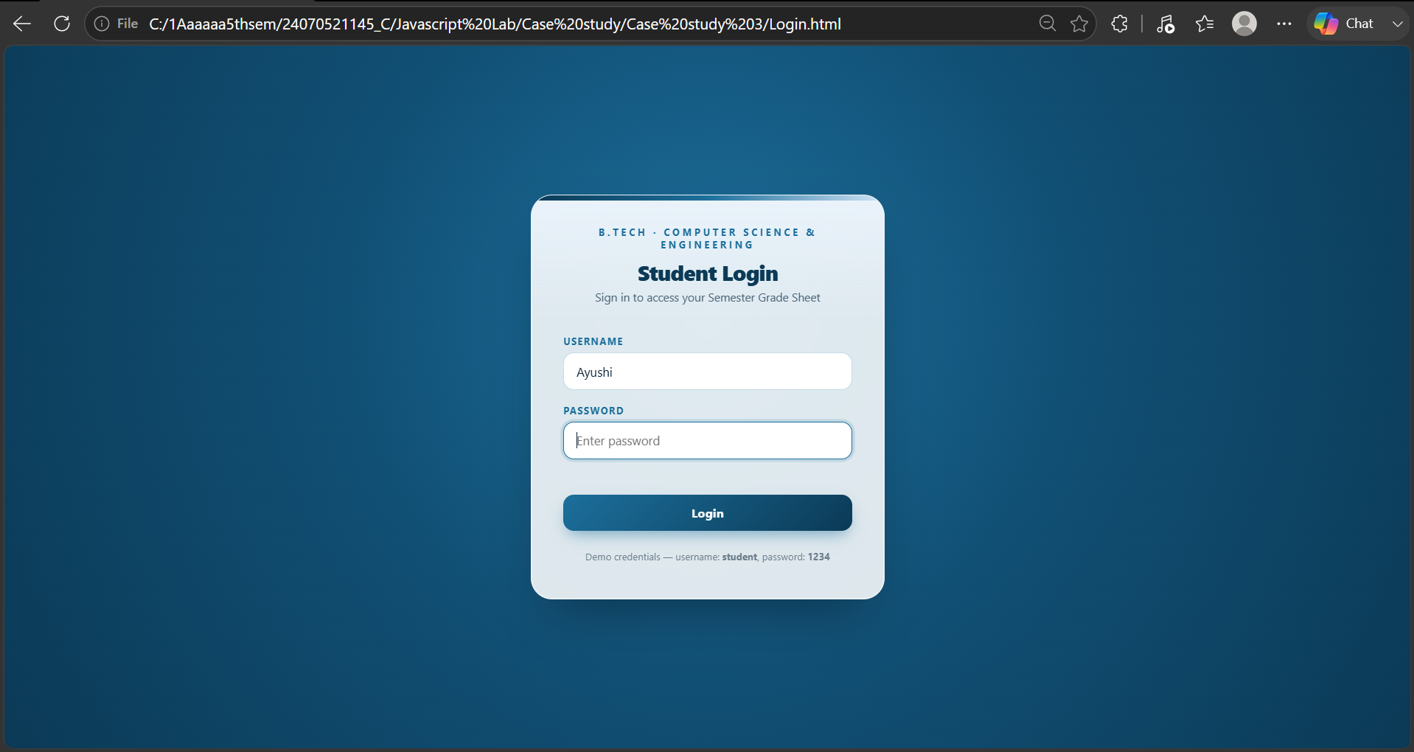
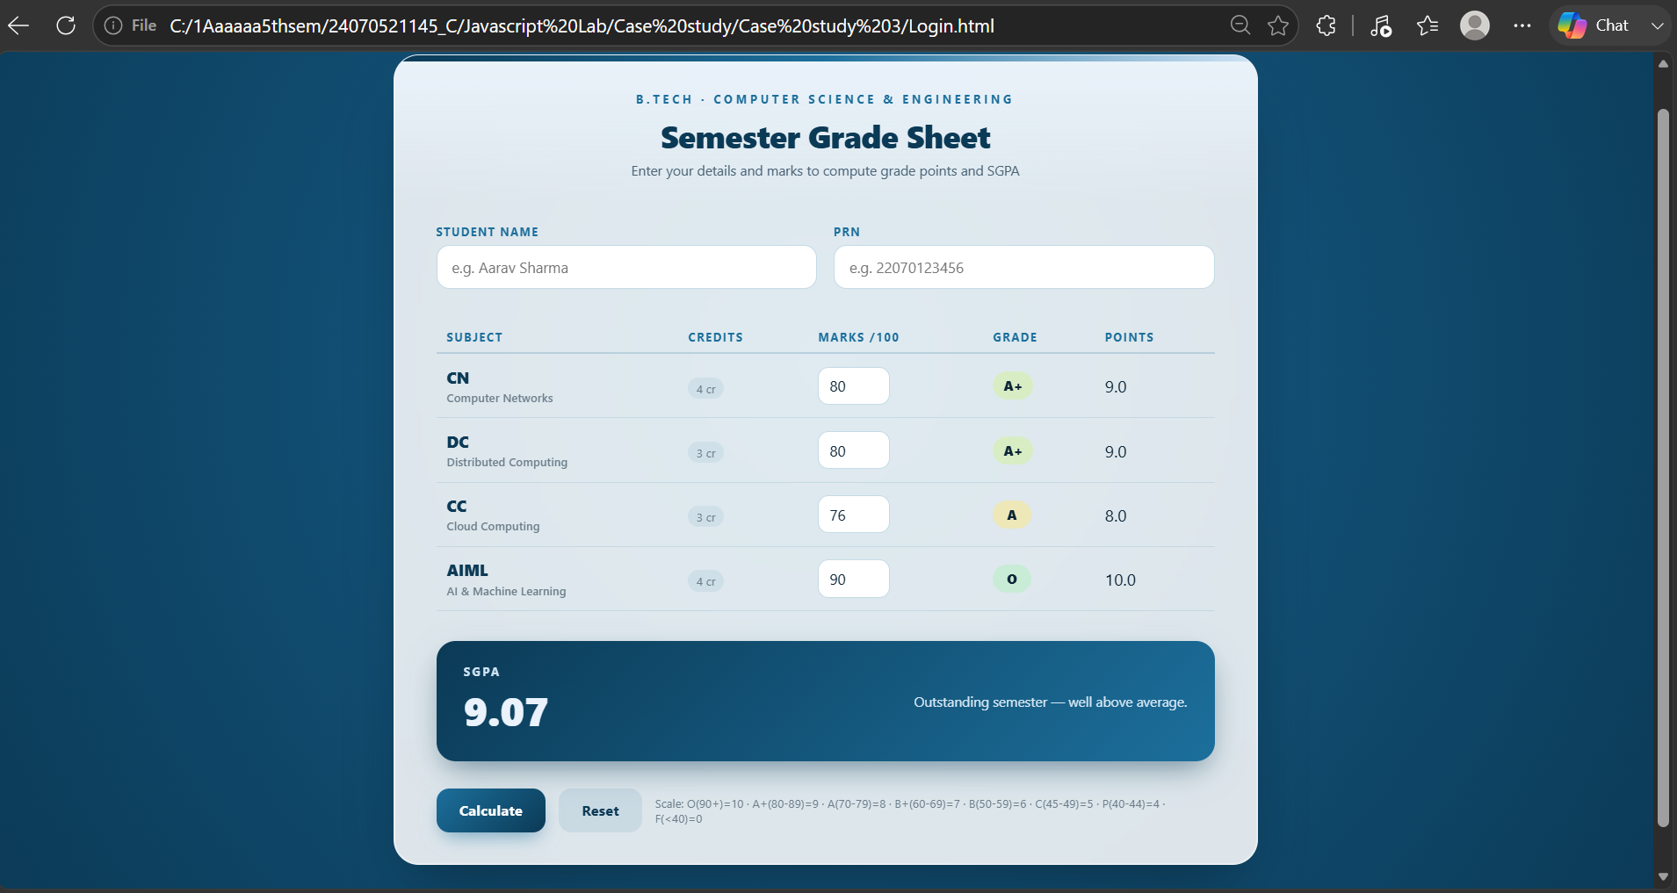
RESULT:
Thus, a web application was successfully designed which allows secure login access using JavaScript and sessionStorage, and calculates a student's SGPA based on entered marks. The program demonstrates the use of DOM manipulation, event handling, conditional logic, and session-based data storage to build a practical, interactive tool.

